Hart Publishing is delighted to be exhibiting at the Obligations conference in Cambridge later this month!

As you will see below, we have published a real
treasure-trove of private law books so far this year

Each of these books, and more, will be on display at the conference
so please feel free to visit our stand to pick up a bargain!

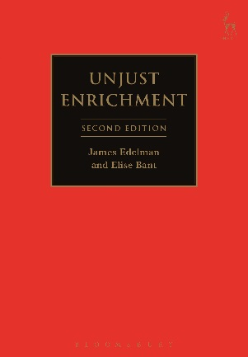
Unjust Enrichment
James Edelman and Elise Bant

Aug 2016 | 9781841133188 | 480pp | Pbk | RSP: £32.99
Discount Price for Obligations List Members: £26.39
Click here for more info and to order online
Enter code CV7 at the checkout to get your discount

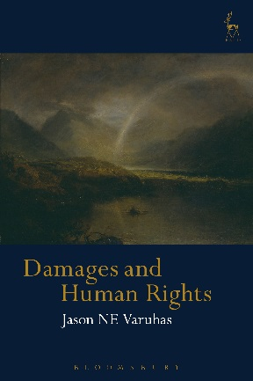
Damages and Human Rights
Jason NE Varuhas

May 2016 | 9781849463720 | 552pp | Hbk | RSP: £95
Discount Price for Obligations List Members: £76
Click here for more info and to order online
Enter code CV7 at the checkout to get your discount

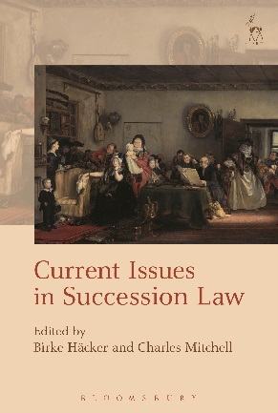
Current Issues in Succession Law
Edited by Birke Häcker and Charles Mitchell

May 2016 | 9781782256274 | 320pp | Hbk | RSP: £70
Discount Price for Obligations List Members: £56
Click here for more info and to order online
Enter code CV7 at the checkout to get your discount

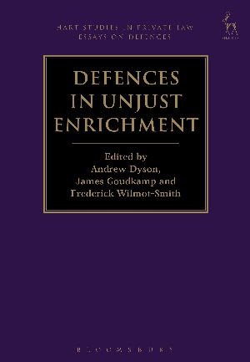
Defences in Unjust Enrichment
Edited by Andrew Dyson, James Goudkamp and Frederick Wilmot-Smith

Jan 2016 | 9781849467254 | 360pp | Hbk | RSP: £75
Discount Price for Obligations List Members: £60
Click here for more info and to order online
Enter code CV7 at the checkout to get your discount

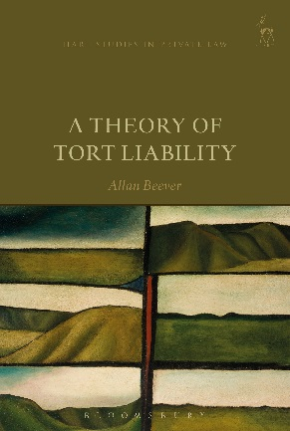
A Theory of Tort Liability
Allan Beever

Aug 2016 | 9781509903184 | 272pp | Hbk | RSP: £55
Discount Price for Obligations List Members: £44
Click here for more info and to order online
Enter code CV7 at the checkout to get your discount

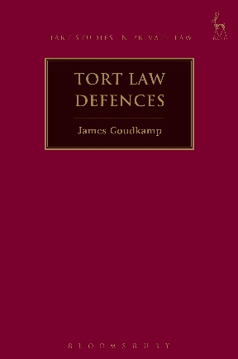
Tort Law Defences
James Goudkamp

Jun 2016 | 9781509905027 | 288pp | New in Pbk | RSP: £30
Discount Price for Obligations List Members: £24
Click here for more info and to order online
Enter code CV7 at the checkout to get your discount

2014 OBLIGATIONS CONFERENCE PROCEEDINGS
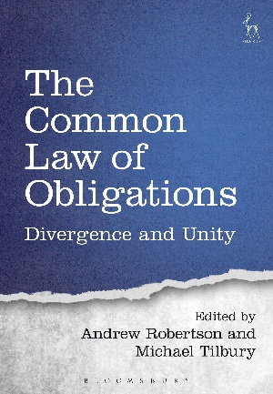
The Common Law of Obligations
Divergence and Unity
Edited by Andrew Robertson and Michael Tilbury

Jan 2016 | 9781782256564 | 376pp | Hbk | RSP: £70
Discount Price for Obligations List Members: £56
Click here for more info and to order online
Enter code CV7 at the checkout to get your discount

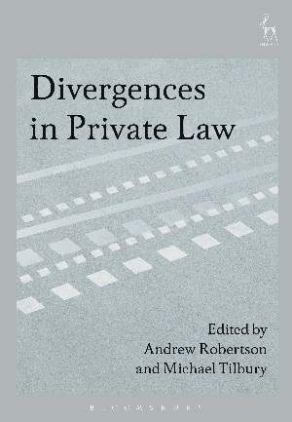
Divergences in Private Law
Edited by Andrew Robertson and Michael Tilbury

Jan 2016 | 9781782256601 | 392pp | Hbk | RSP: £70
Discount Price for Obligations List Members: £56
Click here for more info and to order online
Enter code CV7 at the checkout to get your discount

